First, let us take a slightly deeper look at the anatomy of a port. Ports are intended to represent the points of connectivity of a component: in effect, they form the gateways into and out of the component. By restricting ourselves to components that only interact via their ports we foster re-usability of components and re-purposability (sic) of code.
This is an important point: unlike most programming languages, and unlike Star itself, our diagramming notation does not rely on scoping to communicate between elements. Instead, all connections and references are explicit. This is a strong constraint that helps to enforce so-called loose coupling between components. This greatly simplifies the kinds of task of assembling applications from components.
Ports denote types as well as data flow: each port is associated with an API schema that determines the type of data that is going through the port. For example, the responding port of the SplitComponent has a schema associated with it that shows that the component expects Orders coming in:
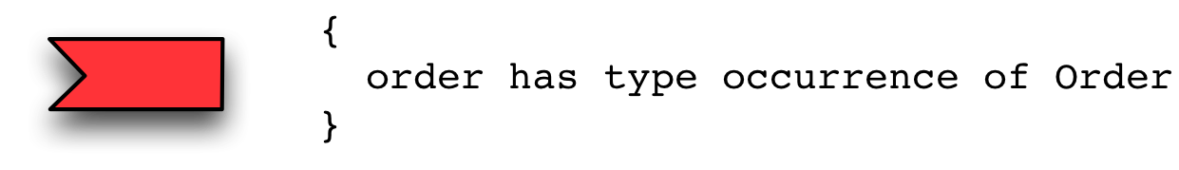
<$Scr_Ps::0>An Order Port
<!$Scr_Ps::0>The originating port will be connected to a data source component. It’s type schema declares what kind of data it is looking for:
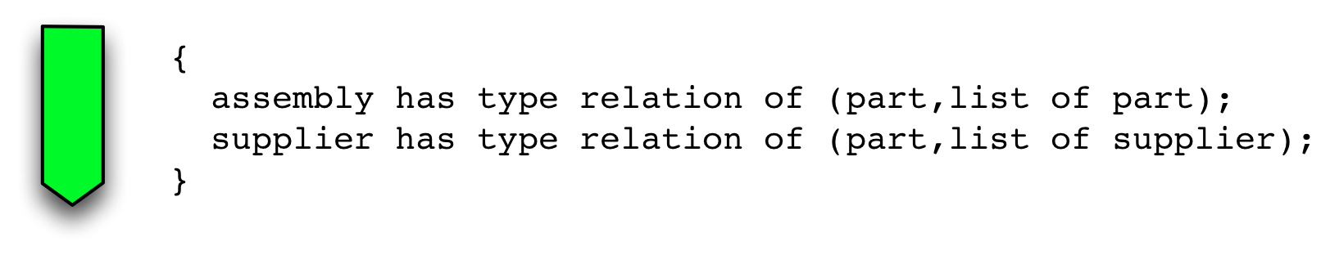
<$Scr_Ps::0>The Parts DB Port
<!$Scr_Ps::0>It should come as no surprise at this point that we also declare that ports are intimately associated with speech actions: communication between components is mediated by speech actions and ports codify both the sender/receiver relationship and the type of communication.
Notice that we are speaking in terms of originating and responding here. This reflects the fact that in any given communication we have an originating speaker and a responding listener. We have deliberately avoided using terms such as input or output here because connections between components can involve both flows of information but only one side ever initiates the action. For example, the SplitComponent will raise a query to the PartsDB component: the query itself involves sending the query in one direction and receiving the data from the PartsDB component in the other.
Our final kind of port is a specialization of the originating port: the publishing port as in:
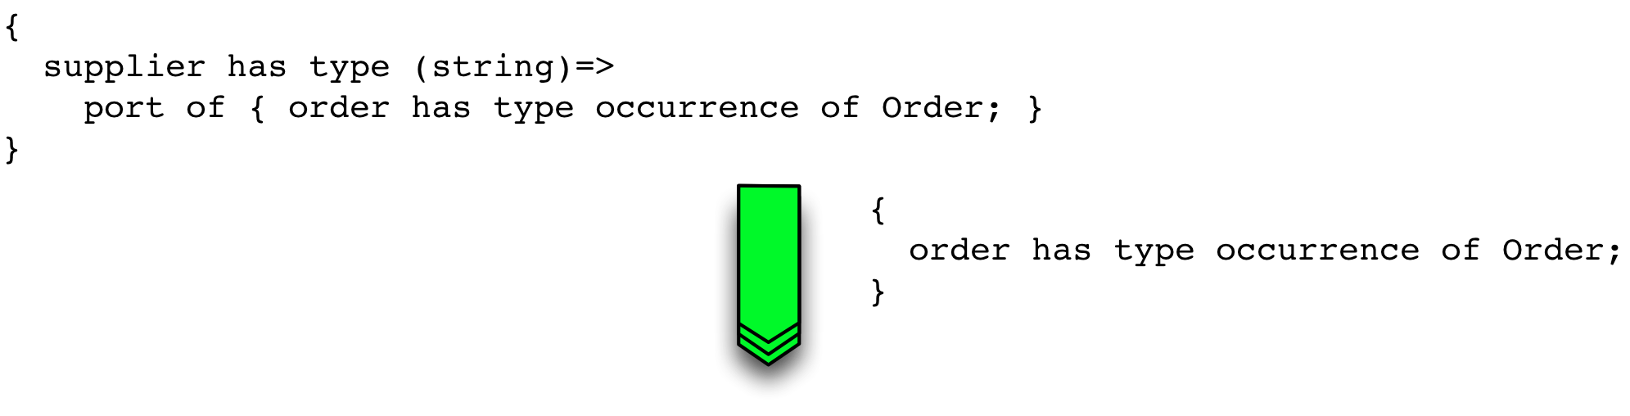
<$Scr_Ps::0>The Supplier Port
<!$Scr_Ps::0>The difference between a normal originating port and a publishing port is two-fold: it represents a one-to-many fan-out – i.e., it may be connected to an arbitrary number of other components – and it also has an additional feature: the discrimination function that will allow the SplitComponent internally to ‘select’ the right supplier to send parts orders to.
The net effect of this is that we have a diagramming notation that supports a high-level modeling of applications that is intuitive to many software engineers. Furthermore, we can support type safety of communication between elements of the application.
This notation is not quite a complete ‘spanning set’ if the end goal is to construct a platform for building a variety of distributed applications. However, it is the kernel of such a set and can easily form the basis of a complete distributed applications platform.

